**Project Design Phase-II**

**Data Flow Diagram & User Stories**

|  |  |
| --- | --- |
| Team ID | PNT2022TMID10342 |
| Project Name | University Admit Eligibility Predictor |
| Maximum Marks | 4 Marks |

**Data Flow Diagrams:**

A Data Flow Diagram (DFD) is a traditional visual representation of the information flows within a system. A neat and clear DFD can depict the right amount of the system requirement graphically. It shows how data enters and leaves the system, what changes the information, and where data is stored.

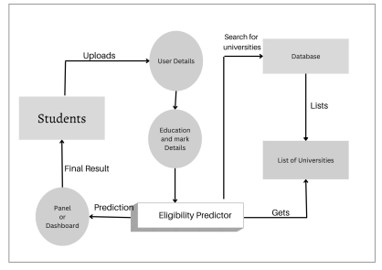

**User Stories**

| **User Type** | **Functional Requirement (Epic)** | **User Story Number** | **User Story / Task** | **Acceptance criteria** | **Priority** | **Release** |
| --- | --- | --- | --- | --- | --- | --- |
| Customer (Mobile user) | Registration | USN-1 | As a user, I can view the cut off marks of previous years in my dashboard | I can access and download the files | High | Sprint-1 |
|  |  | USN-2 | As a user, I can receive university details and their ranking. | I can only view(read-only) | Medium | Sprint-1 |
|  |  | USN-3 | As a user, I can review the experience of the students in the university | I can access the review sections | Medium | Sprint-2 |
|  |  | USN-4 | As a user, I can upload my documents. | I have read and write access to upload files. | High | Sprint-1 |
|  |  | USN-5 | As a user, I can fill out the general and educational details in the form provided | I have read and write access to the forms filled. | High | Sprint-1 |
|  | Predictor | USN-6 | I can view the list of universities in which I am eligible to get an admission | I can receive the final result as whether eligible or not | High | Sprint-2 |
|  |  | USN-7 | I can view the list of universities I am eligible with the same cut-off but in previous years | I can access the files with read-only permission | Medium | Sprint-2 |
| Administrator | Dashboard | USN-8 | As an administrator, I can have access to update the latest updates of the universities | I can have access to read and write the university information in the dashboard | High | Sprint-3 |
|  |  | USN-9 | As an administrator, I can access any resources available in the page. | I can access the resources that are available | Medium | Sprint-3 |
|  |  | USN-10 | As an administrator, I can have a track on the universities the student is eligible to get admission at. | I can access the list of the universities obtained a final result. | High | Sprint-3 |
|  |  |  |  |  |  |  |
|  |  |  |  |  |  |  |